

*A*

*Project Report*

*On*

**SuperStore Sales Analysis**

Submitted in partial fulfillment of the requirement for the award of degree of

**Bachelor of Computer Application (BCA)**

of

**Kavikulguru Kalidas Sanskrit University**

*Submitted by*

**Vishranti Pravin Gharat**

*Under the guidance of*

**Prof. Sneha Shashikant Lokhande**



Kavikulguru Kalidas Sanskrit University’s

**Bakliwal Foundation College of Arts, Commerce and Science**

Vashi.

**BATCH: 2022-2025**



**Kavikulguru Kalidas Sanskrit University**

**Bakliwal Foundation College of Arts , Commerce and Science**

Vashi.

**CERTIFICATE**

This is to certify that the project titled **SuperStore Sales Analysis** undertaken at the Bakliwal Foundation of Arts,Commerce and Science , Vashi , Navi Mumbai by **Miss.Vishranti Pravin Gharat** holding **Seat No.(PRN:2022018100095666)** studying **Bachelor of Computer Application** Semester -VI has been satisfactorily completed as prescribed by the **Kavikulgur Kalidas Sanskrit Vishwavidyalaya** during the year 2024-2025.

**Project In-charge Co-Ordinator**

**External Examiner**

**Internal Examiner Principal**

**Declaration**

I hereby declare that the project work titled **“SUPERSTORE SALES ANALYSIS USING POWER BI”** has been independently carried out and completed by me as a part of the partial fulfillment of the requirements for the award of the degree **Bachelor of Computer Applications** during the academic year **2024–2025**.

This project has been undertaken under the valuable guidance and supervision of **Prof. Sneha Shashikant Lokhande**, whose support, expertise, and consistent feedback were crucial throughout the duration of this work. The analysis, design, implementation, and documentation included in this report are entirely my own original contributions, unless otherwise stated through appropriate citations and references.

I further declare that this project is a genuine and original work, and it has not been previously submitted to this or any other university/institute for the award of any Degree, Diploma, Associateship, Fellowship, or other similar qualifications by me or by any other individual. Any data, figures, or content borrowed from other sources has been duly acknowledged.

This declaration is made with utmost sincerity and in full honesty of the academic integrity upheld by my institution.

.

**Vishranti Pravin Gharat**

## 

## Acknowledgment

I avail this opportunity to express my sincere and deep gratitude to many who are a factor in helping me gain the knowledge and experience during the project and throughout the course.

I have great pleasure in presenting this project. The completion of this project is not merely due to only my own efforts but also due to the guidance given by our professors.

I am thankful to our project guide **Prof. Sneha Shashikant Lokhande** for her support, for their invaluable guidance, motivation, and support throughout the course of this project. Their continuous encouragement and insightful feedback played a pivotal role in the completion of this work.

I extend my sincere thanks to **Principal Dr. Sharadkumar Shah ,Head of Department Prof. Sneha Shashikant Lokhande ,Prof. Shaikh Mohammed Umar ,Prof. Divya Patil ,Prof. Kalyani Kulkarni ,Prof. Ankit Srivastava.**

I am grateful to my family and friends who stood by me during the ups and downs of this project journey.

Last but not the least, I would like to thank all those who directly or indirectly helped me in this endover.

**Table of Contents**

|  |  |  |
| --- | --- | --- |
| **Sr No.** | **Title** | **Page No.** |
| 1 | **Abstract** | 1 |
| 1.1 | Background |  |
| 1.2 | Objectives of the Project |  |
| 1.3 | Scope of the Project |  |
| 1.4 | Methodology |  |
| 1.5 | Tools and Technologies Used |  |
| 1.6 | Organization of the Report |  |
|  |  |  |
| 2 | **Domain Overview** | 3 |
| 2.1 | Overview of sales Analytics |  |
| 2.2 | Importance of Sales Data in Business Decision Making |  |
|  |  |  |
| 3 | **System Analysis** | 4 |
| 3.1 | Problem Statement |  |
| 3.2 | Existing System |  |
| 3.3 | Limitations of the Existing System |  |
| 3.4 | Proposed System |  |
| 3.5 | Advantages of Proposed System |  |
|  |  |  |
| 4 | **System Requirements** | 6 |
| 4.1 | Hardware Requirements |  |
| 4.2 | Software Requirements |  |
|  |  |  |
| 5 | **Data Collection and Preprocessing** | 7 |
| 5.1 | Data Source Details |  |
| 5.2 | Data Cleaning |  |
| 5.3 | Data Transformation |  |
| 5.4 | Data Modeling |  |
|  |  |  |
| 6 | **System Design** | 8 |
| 6.1 | Architecture Diagram |  |
| 6.2 | Data Flow Diagram (DFD) |  |
| 6.3 | ER Diagram |  |
| 6.4 | Schema Design |  |
|  |  |  |
| 7 | **Implementation** | 12 |
| 7.1 | Introduction to Power BI |  |
| 7.2 | Features of Power BI Used |  |
| 7.3 | Power Query Editor |  |
| 7.4 | DAX Formulas and Measures |  |
|  |  |  |
|  |  |  |
| 8 | **Dashboard Design and Visualizations** | 14 |
| 8.1 | Sales Overview Dashboard |  |
| 8.2 | Region-wise Sales |  |
| 8.3 | Product Category-wise Sales |  |
| 8.4 | Sales by Time (Year/Month/Quarter) |  |
|  |  |  |
| 9 | **Insights and Interpretation** | 16 |
| 9.1 | Key Insights Extracted |  |
| 9.2 | Business Value and Decision Support |  |
|  |  |  |
| 10 | **Testing and Validation** | 17 |
| 10.1 | Data Accuracy |  |
| 10.1.1 | Data Source Verification |  |
| 10.1.2 | Cross-Verification |  |
| 10.1.3 | Test for Data Integrity in Calculations |  |
| 10.2 | Visualization Validation |  |
| 10.2.1 | Consistency in Design |  |
| 10.2.2 | KPI Accuracy |  |
| 10.2.3 | Test Cases |  |
|  |  |  |
| 11 | **Limitations of the Project** | 22 |
| 11.1 | Data Quality and Completeness |  |
| 11.2 | Data Granularity |  |
| 11.3 | Complexity of the Dataset |  |
| 11.4 | Limitations of Power BI |  |
| 11.5 | User Dependency |  |
| 11.6 | Integration with External Systems |  |
|  |  |  |
| 12 | **Future Enhancements** |  |
| 12.1 | Real-Time Data Integration | 25 |
| 12.2 | Predictive and Advanced Analytics |  |
| 12.3 | Improved Security and Access Control |  |
|  |  |  |
| 13 | **Appendix and Screenshots** |  |
| 13.1 | Overview Dashboard | 27 |
| 13.2 | KPI Visuals |  |
| 13.3 | DAX Measures |  |
| 13.4 | Glossary |  |
| 13.5 | Source Code (if applicable) |  |
|  |  |  |
| 14 | **Conclusion** | 33 |
|  |  |  |
| 15 | **References** | 34 |

**1.ABSTRACT**

**1.1 Background**

In today’s competitive marketplace, businesses rely on accurate and timely data to drive sales strategies and improve performance. Traditional methods of sales analysis, such as manual reporting or basic spreadsheets, often fall short when it comes to managing large datasets and providing real-time insights. Power BI, a leading business intelligence tool, helps businesses transform raw data into actionable insights. By enabling the integration of various data sources and providing interactive visualizations, Power BI empowers sales teams to track performance, understand customer behavior, and identify trends. This project demonstrates how Power BI can be utilized to analyze sales data, improve decision-making, and optimize sales strategies in a modern business environment.

**1.2 Objectives of the Project**

* Integrate sales data from various sources to create a unified dashboard for analysis.
* Develop interactive reports to visualize key metrics such as total sales, revenue growth, and product performance.
* Use DAX to create custom calculations for deeper analysis, such as profit margins and sales trends.
* Enable real-time access to reports for stakeholders to make informed, data-driven decisions.
* Provide insights to help optimize sales strategies and forecast future sales based on historical data.

**1.3 Scope of the Project**

This project focuses on the use of Power BI to analyze sales data across multiple dimensions, including time, products, and customer segments. It involves collecting data from various sources, transforming it, and creating a data model that links sales transactions, customer information, and product details. The project will include the creation of interactive dashboards that provide insights into sales trends, product performance, and regional variations. The analysis will also incorporate time intelligence features to track performance over different periods (e.g., monthly, quarterly, yearly). While the project will cover the visualization of past and current sales data, it will not include real-time data collection or inventory management systems.

**1.4 Methodology**

The project follows a structured approach:

1. **Data Collection**: Gather sales transaction, customer, and product data from sources such as Excel, SQL, and cloud services.
2. **Data Transformation**: Use Power Query in Power BI to clean and reshape the data for analysis.
3. **Data Modeling**: Build relationships between fact tables (sales data) and dimension tables (customers, products, time).
4. **DAX Calculations**: Create custom measures like total sales, YTD sales, and profit margins using DAX.
5. **Report Creation**: Design interactive dashboards to visualize key metrics and trends.
6. **Analysis**: Analyze the visualizations to gain insights into sales performance and forecast future trends.
7. **Optimization**: Continuously refine reports based on feedback to ensure they meet business needs.

**1.5 Tools and Technologies Used**

* **Power BI**: The main tool used for data visualization, reporting, and dashboard creation.
* **Power Query**: For data cleaning, transformation, and integration from multiple sources.
* **DAX (Data Analysis Expressions)**: Used for creating custom calculations and measures such as sales growth, profit margins, and forecasts.
* **Excel**: For preliminary data organization and integration with Power BI.
* **SQL Databases**: For querying and integrating large sales datasets stored in relational databases.
* **Power BI Service**: To publish and share reports with stakeholders in a collaborative environment.

**1.6 Organization of the Report**

The report is organized into sixteen chapters. It begins with an introduction and company profile, followed by analysis and design chapters. It continues through implementation, testing, results, and ends with future scope, references, and appendices.

**2.Domain Overview**

### 2.1 Overview of Sales Analytics

### Sales analytics refers to the process of collecting, analyzing, and interpreting sales data to improve business performance. It involves the use of data visualization tools and statistical techniques to track key metrics such as revenue, sales volume, customer acquisition, product performance, and regional trends. By leveraging historical and real-time sales data, organizations can identify patterns, forecast future trends, and optimize their sales strategies. Tools like Power BI empower businesses to transform raw data into interactive dashboards and meaningful insights. This makes it easier for stakeholders to monitor performance and make informed decisions quickly. Sales analytics not only improves efficiency but also helps align marketing and operational efforts with business goals.

**2.2 Importance of Sales Data in Business Decision Making**

Sales data plays a vital role in strategic business decision-making. Accurate and timely analysis of sales figures enables businesses to understand market demand, customer preferences, and sales performance across various segments. It provides insights into which products or services are performing well, which regions are driving revenue, and where improvements are needed. With the help of data-driven decision-making, companies can allocate resources more effectively, identify growth opportunities, and reduce operational inefficiencies. Power BI, in particular, enhances this process by offering real-time dashboards and drill-down reports that simplify complex data, ensuring that decisions are based on facts rather than assumptions. In today’s competitive market, leveraging sales data is essential for maintaining a competitive edge and driving long-term business success

**3.System Analysis**

**3.1 Problem Statement**

In many organizations, sales data is stored in large, unorganized spreadsheets or outdated systems that make it difficult to analyze and interpret effectively. This lack of real-time insights and visual representation leads to delayed decision-making, missed business opportunities, and reduced operational efficiency.

**3.2 Existing System**

The traditional system of analyzing sales data often involves manual data entry and the use of static tools like Excel. These systems are time-consuming, prone to human errors, and do not provide interactive dashboards or detailed visualizations. Reports are often limited in scope, lacking dynamic filtering and drill-down capabilities.

**3.3 Limitations of Existing System**

* Time-consuming report generation
* Lack of real-time data updates
* Limited visual insights and interactivity
* Difficulty in identifying trends and patterns
* No centralized platform for stakeholder collaboration

**3.4 Proposed System**

The proposed system leverages Uber trip data to build a dynamic, interactive Power BI dashboard. It will offer:

* Visual analytics on total trips, revenue, vehicle usage
* Time-based insights (hourly, daily, monthly trends)
* Filters and drill-downs for region, date, vehicle, and more
* DAX-based calculations for KPIs and custom metrics

**3.5 Advantages of Proposed System**

* Real-time, interactive dashboards
* Automated data refresh and transformation
* Enhanced data visualization and storytelling
* Informed decision-making based on insights
* Easy-to-use interface for both technical and non-technical users

**3. 6 Feasibility Analysis**

* **Technical Feasibility**: Power BI integrates well with Excel, CSV, SQL, and other data sources.
* **Economic Feasibility**: Power BI Desktop is free to use, with cost-effective upgrade options.
* **Operational Feasibility**: Easy to use for managers and analysts with minimal training.

**4.System Requirements**

**4.1 Hardware Requirements**

To ensure smooth functioning of the Power BI dashboards and data processing, the following hardware specifications are recommended:

* Processor: Intel Core i5 or higher (or equivalent AMD processor)
* RAM: Minimum 8 GB (16 GB recommended for large datasets)
* Hard Disk: At least 1 GB of free disk space for Power BI Desktop and project files
* Display: 1366 x 768 resolution or higher (Full HD recommended)
* Internet Connection: Required for accessing Power BI cloud services, online data sources, and publishing reports.

**4.2 Software Requirements**

The software tools and technologies used in this project include:

* **Operating System**: Windows 10 or later (Power BI Desktop is primarily Windows-based)
* **Power BI Desktop**: Latest version for developing and publishing dashboards
* **Microsoft Excel**: For preliminary data cleaning and formatting (if required)
* **Database or File Source**: CSV, Excel, or any structured data source used for sales data
* **Web Browser**: Google Chrome, Microsoft Edge, or Firefox (for accessing Power BI Service)
* **Microsoft Power BI Service (optional)**: For sharing and publishing dashboards online

These requirements ensure a stable and efficient environment for building, testing, and deploying interactive sales dashboards using Power BI.

**5. Data Collection and Preprocessing**

**5.1 Data Source Details**

The data used in this project was sourced from a structured Excel file containing sales transactions. The dataset includes key fields such as **Order ID, Product Category, Sales Amount, Quantity, Region, Customer Name, Date of Sale**, and **Profit**. This data represents sales performance across different regions, time periods, and product categories, providing a solid foundation for meaningful business insights.

**5.2 Data Cleaning**

Before analysis, the data was cleaned using Power BI's **Power Query Editor**. This included:

* Removing duplicate rows
* Handling missing or null values
* Standardizing date and currency formats
* Correcting inconsistent text entries (e.g., region or product names)  
  These steps ensured that the data was reliable, consistent, and ready for further transformation.
* Removal of null or blank values
* Filtering irrelevant columns
* Correction of date/time formats
* Standardizing location and vehicle fields

**5.3 Data Transformation**

* Added calculated columns for additional insights (e.g., trip duration, fare per km)
* Merged date and time for timestamp analysis
* Created time hierarchy (Year, Month, Day, Hour)

**5.4 Data Modeling**

* Implemented a **star schema** model:

1. **Fact Table**: Sales transactions
2. **Dimension Tables**: Products, Regions, Customers, Dates

* Defined relationships between tables using primary/foreign keys.
* Ensured one-to-many relationships for accurate filtering.
* Enabled efficient slicer and filter functionalities in dashboard.

**6.System Design**

**6.1 Architecture Diagram**

**1. Architecture Diagram**

**The architecture involves:**

* **Data Source Layer: Raw data from Excel or SQL.**
* **Power Query Layer: Data cleansing and transformation.**
* **Data Modeling Layer: Relationship mapping and DAX measures.**
* **Visualization Layer: Dashboards and reports.**

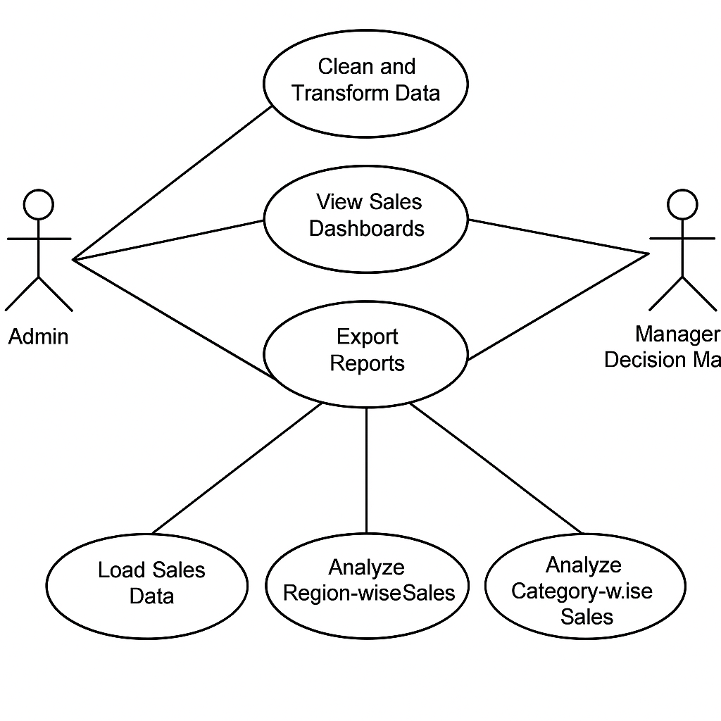

**6.2 Data Flow Diagram (DFD)**

• **Level 0** gives a top-down view: source → system → output.

• **Level 1** expands the system into Power Query, Data Modelling, and Reporting layers.

• Each process block can be customized with more detail (e.g., adding drill-through, bookmarks, tooltips).

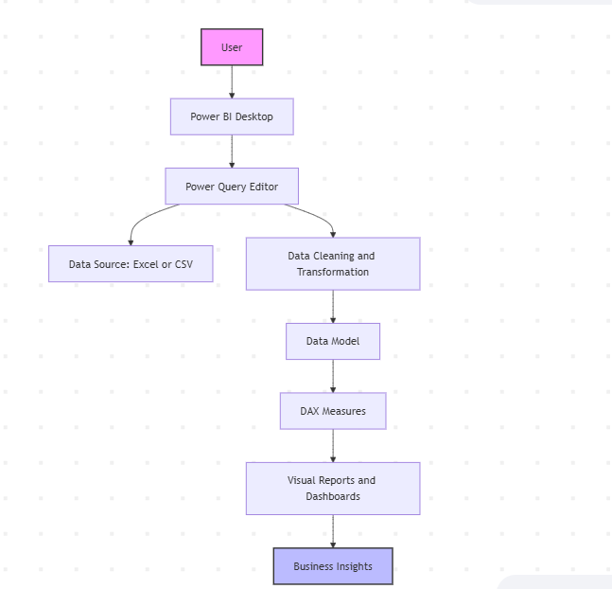

**6.3 ER Diagram**

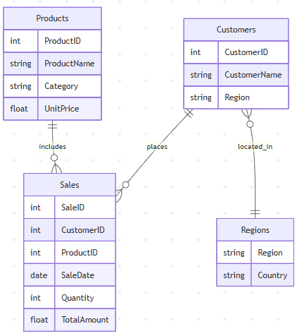An **Entity-Relationship (ER) Diagram** will provide an overview of how different data entities are related, reflecting the structure of the data.

**💡 What This Represents:**

1. **Sales**
   * Attributes: Sales_ID, Date, Customer_ID, Product_ID, Quantity, Total_Price, Payment_Method, Salesperson_ID
2. **Products**
   * Attributes: Product_ID, Product_Name, Category, Price, Stock_Quantity
3. **Customers**
   * Attributes: Customer_ID, Name, Email, Address, Phone
4. **Salesperson**
   * Attributes: Salesperson_ID, Name, Email, Region
5. **Orders**
   * Attributes: Order_ID, Customer_ID, Order_Date, Total_Amount
6. **Payments**
   * Attributes: Payment_ID, Sales_ID, Payment_Date, Amount_Paid, Payment_Method
7. **Regions**
   * Attributes: Region_ID, Region_Name

**Relationships:**

* **Sales** to **Customers**: Many-to-One (A customer can have many sales records)
* **Sales** to **Products**: Many-to-One (A sale can include only one product, but a product can appear in many sales)
* **Sales** to **Salesperson**: Many-to-One (A salesperson can make many sales)
* **Orders** to **Customers**: Many-to-One (A customer can have many orders)
* **Payments** to **Sales**: One-to-One (Each sale has a corresponding payment)
* **Salesperson** to **Regions**: Many-to-One (A salesperson belongs to one region)

**6.4 Schema Design**

The **Schema Design** organizes data into several key entities such as **Customers**, **Orders**, **Products**, **Sales**, **Salesperson**, **Payments**, **Suppliers**, **Categories**, and **Regions**. These entities are connected through relationships like one-to-many (e.g., Customers to Orders) and many-to-one (e.g., Products to Suppliers).

* **Customers** place **Orders**, which contain **Sales**.
* Each **Sales** record involves a **Product**, made by a **Salesperson**.
* **Payments** are linked to **Sales** to track payment details.
* **Products** belong to **Categories** and are provided by **Suppliers**.
* **Salespersons** work in specific **Regions**.

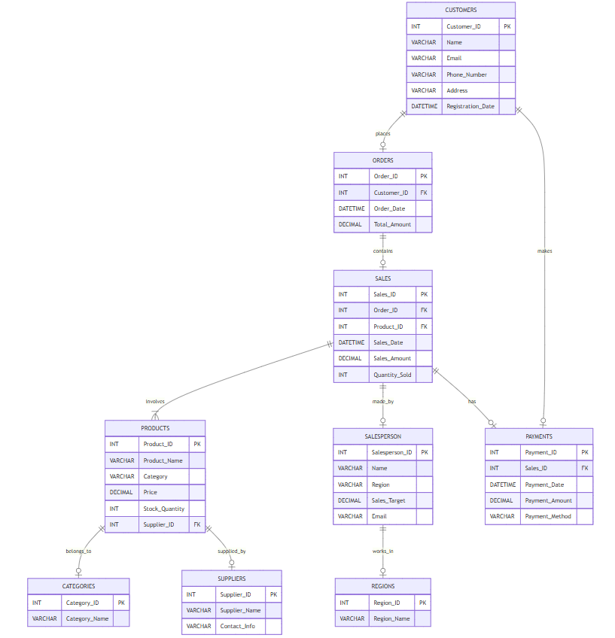

**7.** **Implementation**

**7.1 Introduction to Power BI**

Power BI is a powerful business analytics tool developed by Microsoft that enables users to visualize data and share insights across an organization. It provides interactive dashboards, real-time analytics, and seamless integration with various data sources like Excel, SQL Server, cloud services, and more. Power BI transforms raw data into meaningful reports and helps decision-makers monitor performance and identify trends effectively**.**

**7.2 Features of Power BI Used**

In this sales project, several key features of Power BI were utilized:

* **Interactive Dashboards:** Visual reports with filters, slicers, and drill-down capabilities.
* **Data Import and Integration:** Connected to Excel/CSV files containing sales data.
* **Custom Visuals:** Used bar charts, line graphs, pie charts, tables, and KPIs for effective representation.
* **Real-time Refresh:** Enabled scheduled data refresh for up-to-date reporting.
* **Bookmarks and Tooltips:** Improved user navigation and added additional context to visuals.

**7.3 Power Query Editor**

The Power Query Editor was used extensively for data preparation. It allowed the cleaning and transformation of raw sales data before loading it into the data model. Key actions included:

* Removing duplicates and null values
* Filtering and sorting data
* Splitting/merging columns
* Changing data types
* Creating new columns through transformations  
  These steps ensured that the dataset was clean, consistent, and ready for analysis.

**7.4 DAX Formulas and Measures**

DAX (Data Analysis Expressions) was used to create calculated columns and measures for deep analytical insights. Important measures created include:

* **Total Sales** = SUM(Sales[Sales Amount])
* **Total Profit** = SUM(Sales[Profit])
* **Profit Margin** = DIVIDE([Total Profit], [Total Sales])
* **Yearly Sales Growth**, **Top-Selling Products**, and more  
  These DAX formulas enhanced the flexibility and analytical capability of the dashboards.

**8.** **Dashboard Design and Visualizations**

In this project, multiple interactive dashboards were created using Power BI to visualize and analyze different aspects of the sales data. Each dashboard provides insights into specific dimensions such as time, region, product category, and customer trends, helping stakeholders make data-driven decisions.

**8.1 Sales Overview Dashboard**

* Displays key performance indicators (KPIs):
* **Total Sales**
* **Total Profit**
* **Total Orders**
* **Profit Margin**
* Uses bar charts and donut charts to visualize overall sales distribution.
* Includes slicers for filtering data by region, time, and product.
* Provides a snapshot of business performance at a glance.

**8.2 Region-wise Sales**

* Uses **map visualizations** to represent geographical sales data.
* Bar charts compare **sales** and **profits** across different regions.
* Highlights top-performing and underperforming regions.
* Helps businesses target regions with growth potential or declining sales.

**8.3 Product Category-wise Sales**

* Uses **stacked bar charts** and **tree maps** for category-wise comparison.
* Displays performance of each **product category** and **sub-category**.
* Allows **drill-down** into specific product lines for deeper analysis.
* Helps identify high-performing products and areas for improvement.

**8.** **4 Sales by Time (Year/Month/Quarter)**

* Line and area charts show **sales trends over time**.
* Provides breakdowns by **Year**, **Quarter**, and **Month**.
* Includes a **date slicer** to filter data by custom time ranges.
* Reveals seasonal trends and peak business periods for planning and forecasting.

**8.** **5 Top Customers and Trends**

* Highlights the **Top 10 Customers** based on sales and frequency.
* Uses tables, bar charts, and pie charts to show:
* Customer-wise sales contribution
* Repeat purchase behavior
* Profitability per customer
* Supports customer segmentation and marketing strategy.

**9.** **Insights and Interpretation**

**9.1 Key Insights Extracted**

• The sales dashboard revealed that the **majority of revenue** came from a few **specific regions**, with others contributing significantly less. This suggests an opportunity to expand marketing and sales efforts in underperforming regions.

• **Top product categories** were identified, showing that certain product lines consistently outperform others in both sales volume and profit. These should be prioritized in inventory management and promotions.

• The **time-series analysis** uncovered **seasonal trends**, with sales peaking in specific months or quarters. This is valuable for planning future marketing campaigns, stock levels, and workforce allocation.

• **Customer segmentation** showed that a small percentage of customers contributed a large portion of sales, following the Pareto principle (80/20 rule). This highlights the importance of nurturing high-value customers with loyalty programs or targeted offers.

• Analysis of **profit margins** showed variations across regions and product types. Some high-selling products had low margins, indicating the need to reassess pricing strategies or reduce costs.

### 9 .2 Business Value and Decision Support

• **Real-Time Insights**: Dashboards provide decision-makers with clear, interactive visual data, reducing dependency on manual reports.

• **Targeted Marketing**: By identifying top customers and high-performing products, campaigns can be better focused for higher ROI.

• **Granular Analysis**: Region, category, and time-based filters enable in-depth root cause analysis for performance dips or spikes.

• **Accurate Forecasting**: Sales trends help in setting realistic goals, forecasting future performance, and planning resources effectively.

• **Inventory Planning**: Insights help maintain optimal stock levels, avoiding losses from excess inventory or missed sales due to stockouts.

• **Strategic Decision-Making**: Enables informed business decisions around pricing, promotions, and expansion with confidence.

**10.** **Testing and Validation**

#### 10.1 Data Accuracy Checks

Data accuracy is fundamental in generating reliable insights. In this project, ensuring the integrity of the data is achieved through several steps:

• **Data Source Verification**

* Cross-check the source files (Excel, databases, cloud services) to ensure data consistency.
* Ensure that data imported from external sources (e.g., CRM or ERP systems) is accurate and up to date.

• **Data Cleaning**

* Use Power Query to remove duplicates, correct errors, and handle missing values.
* Apply transformations to standardize data formats (e.g., date formats, text case).
* Handle outliers and extreme values by setting thresholds or excluding them from analysis if necessary.

• **Cross-Verification**

* Compare key metrics (total sales, revenue, and customer counts) against source data or previous reports.
* Validate any transformations applied to the data (e.g., aggregations, merges) to ensure they produce the intended results.

• **Data Profiling**

* Profile the dataset to detect any anomalies, such as inconsistent data or unusual patterns (e.g., missing sales transactions or zero values).
* Identify any null values and decide how to handle them (e.g., imputation or exclusion).

• **Test for Data Integrity in Calculations**

* Perform manual calculations to verify the accuracy of complex metrics (e.g., profit margins, year-over-year growth).
* Use sample data to test DAX formulas and calculated fields to ensure they yield correct results.

• **Data Refresh Validation**

* Monitor data refresh schedules to ensure that the Power BI dataset updates as expected.
* Cross-check the refreshed data against the historical dataset to confirm there are no discrepancies after the refresh.
* during the update process.

#### 10. 2 Visualization Validation

Once the data is cleaned and transformed, ensuring that the visualizations are accurate and meaningful is equally important. The following steps are taken to validate the visualizations:

• **Consistency in Design**

* Ensure that charts and graphs accurately represent data points (e.g., pie chart percentages sum to 100%).
* Verify that visualizations match business expectations and objectives (e.g., showing sales growth, product performance).
* Double-check color coding, legends, and axis labels for clarity and consistency.

• **KPI Accuracy**

* Cross-validate key performance indicators (KPIs) such as sales totals, growth rates, and profit margins.
* Verify custom DAX measures (e.g., sales YTD or product-specific profit margins) by manually comparing results with standard calculations.

• **Interactivity Testing**

* Test slicers, filters, and drill-down capabilities to ensure they work as intended, allowing users to explore data interactively.
* Ensure the interactivity of charts (e.g., clicking on a bar chart to filter data on the dashboard).
* Check that drill-through functionality takes users to detailed views with the correct filtered data.

• **Performance Testing**

* Test the responsiveness of Power BI reports by interacting with large datasets and verifying the load time for visualizations.
* Optimize visualizations by reducing the complexity of DAX measures or simplifying queries to improve dashboard performance.
* Validate that the reports maintain their performance across devices (desktop, tablet, and mobile).

• **Validation Against Business Logic**

* Ensure that visualizations reflect real business logic, such as accurate sales breakdown by region or product category.
* Double-check business rules for segmentation (e.g., customer segmentation, time-based analysis) to ensure data is categorized properly.

• **Usability Testing**

* Check whether users can easily navigate and understand the visualizations without confusion.
* Test whether tooltips and hover actions provide the right contextual information to users.
* Review the clarity of labels, legends, and titles to ensure that they are intuitive and informative.

• **Cross-Device Validation**

* Test the responsiveness of dashboards on different screen sizes and ensure that visuals are rendered correctly.
* Validate that reports are legible and easy to navigate on mobile devices, with proper scaling and layout adjustments.

**10.3 Test Cases:**

1. **Component Name: Dashboard/Main Screen**

Purpose: To verify successful launch and visibility of main dashboard elements

|  |  |  |  |  |  |
| --- | --- | --- | --- | --- | --- |
| Sr no. | Test Case | Test Input | Expected Output | Actual Output | Remark |
| 1 | Check if the Sales Dashboard opens correctly | Open Power BI file | Sales Dashboard should be displayed | Sales Dashboard displayed properly | Passed |
| 2 | Check presence of total sales KPI card | View KPI section | Total Sales card should be visible | Total Sales card is visible | Passed |
| 3 | Check slicer filters for Region are functioning | Select Region in slicer | Report visuals should update as per selected region | Report visuals updated correctly | Passed |

1. **Component Name: Sales Trend Visualization**

Purpose: Validate line chart behavior and data accuracy

|  |  |  |  |  |  |  |
| --- | --- | --- | --- | --- | --- | --- |
| Sr no. | Test Case | Test Input | Expected Output | Actual Output | Remark |  |
| 4 | Check if line chart for Monthly Sales displays correctly | Navigate to trend chart | Line chart should show monthly trend of sales | Monthly trend displayed properly | Passed |  |
| 5 | Check tooltip values on hovering over data points | Hover over chart point | Tooltip should display correct month and sales value | Tooltip displays correct info | Passed |  |

1. **Component Name: Product-wise Sales**

Purpose: Validate bar chart visuals and interactivity

|  |  |  |  |  |  |
| --- | --- | --- | --- | --- | --- |
| Sr no. | Test Case | Test Input | Expected Output | Actual Output | Remark |
| 6 | Check bar chart displays products with correct sales values | View Product Sales chart | Each bar should reflect sales per product | Bar chart displays correct values | Passed |
| 7 | Test click on a product filters other visuals | Click a bar on chart | Other visuals should filter based on selected product | Other visuals filter accordingly | Passed |

1. **Component Name: Region-wise Sales Analysis**

Purpose: Validate map or region-level visual accuracy

|  |  |  |  |  |  |
| --- | --- | --- | --- | --- | --- |
| Sr no. | Test Case | Test Input | Expected Output | Actual Output | Remark |
| 8 | Check if map or region chart is loading properly | View Regional visual | Sales by Region should be plotted accurately | Map/Region visual loads fine | Passed |
| 9 | Check filter works for a specific country/region | Select specific region | Data should update for selected region | Data updated successfully | Passed |

1. **Component Name: KPI Cards**

Purpose: Validate visibility and calculation of KPIs

|  |  |  |  |  |  |
| --- | --- | --- | --- | --- | --- |
| Sr no. | Test Case | Test Input | Expected Output | Actual Output | Remark |
| 10 | Check if Total Revenue KPI is correct | View Total Revenue Card | Value matches with data model calculation | Value matches expected total | Passed |
| 11 | Check if Total Units Sold KPI is shown correctly | View Units Sold Card | Card shows accurate count of units sold | Accurate value displayed | Passed |

**11.** **Limitations of the Project**

**11.1** **Data Quality and Completeness**

* **Missing or Inaccurate Data**: Some sales transactions may be missing or inaccurate due to data entry errors, incomplete records, or delays in data syncing between systems.
* **Data Integrity Issues**: Discrepancies in the data due to inconsistent formats or duplicate records may impact the accuracy of the insights.
* **Data Gaps**: Certain data points, such as customer demographic information or product-specific details, may be unavailable or incomplete, limiting the depth of analysis.

**11.2** **Data Granularity**

* **Limited Detail Level**: The data may be aggregated at higher levels (e.g., monthly or quarterly), making it difficult to capture day-to-day fluctuations or sudden changes in sales trends.
* **Inability to Perform Micro-Level Analysis**: Without granular data (e.g., by hour or by transaction), it's challenging to gain insights into specific events, promotions, or micro-trends that could influence short-term decisions.

**11.3** **Complexity of the Dataset**

* **Data Relationships**: The dataset may include complex relationships between multiple tables (e.g., customers, products, and sales), which can lead to difficulties in data modeling or inaccurate relationships.
* **Challenges with DAX Calculations**: Complex calculations using DAX (Data Analysis Expressions) can sometimes lead to performance issues or errors in KPIs and calculated fields if not properly implemented.
* **Data Merging Issues**: Combining data from multiple sources can create inconsistencies in terms of structure, leading to potential mismatches in key metrics like sales, customer segmentation, or inventory.

**11.4** **Limitations of Power BI**

* **Large Dataset Performance**: While Power BI can handle sizable datasets, performance issues may arise when dealing with exceptionally large datasets, especially in terms of report load times and interactivity.
* **Data Refresh Constraints**: Power BI limits the frequency of data refreshes, and in some cases, real-time data analysis may not be possible due to these refresh schedules.
* **Memory and Data Size Constraints**: Power BI’s memory limitations might restrict the amount of data that can be loaded into the system, which may limit the scope of analysis, especially for enterprises with extensive historical data.

**11.5** **User Dependency**

* **Interpretation Skills**: The effectiveness of the reports depends on the users' ability to interpret the visualizations correctly. Users without a strong understanding of data analysis may misinterpret the results, which can lead to incorrect business decisions.
* **Limited Training**: If users have limited exposure to Power BI, they may struggle with navigating the interactive features of the reports (e.g., filters, slicers, or drill-throughs), leading to inefficient use of the dashboards.
* **Over-Reliance on Automation**: There is a risk that users may become too dependent on automated reports and fail to critically analyze the context of the data or consider external factors influencing sales.

**11.6** **Integration with External Systems**

* **Data Source Compatibility**: Power BI connectors may not support all external systems (e.g., legacy systems or certain third-party APIs), causing issues in data integration.
* **Data Silos**: Different departments or systems may use separate databases, creating silos of information that are hard to consolidate and harmonize for a unified view of sales data.
* **Timeliness of Data Updates**: Delays in syncing data from external systems to Power BI may impact the freshness of the insights, which is critical for decision-making, particularly in fast-moving markets.

**12. Future Scope and Enhancements**

The SuperStore Sales dashboard successfully analyzes key performance indicators, identifies trends, and helps in informed decision-making. However, there is significant scope for further development and improvement to enhance the effectiveness, scalability, and intelligence of the dashboard system. The following are key areas where future enhancements can be made:

**1. Real-Time Data Integration**

* **Live Dashboards**: Integrate APIs to pull live data from e-commerce or POS systems for real-time updates.
* **Streaming Data**: Use Microsoft Power BI streaming datasets for continuous monitoring of KPIs.

**2. Predictive and Advanced Analytics**

* **Sales Forecasting**: Implement machine learning models to forecast future sales volumes.
* **Customer Behavior Prediction**: Use AI to predict customer churn or buying patterns.
* **Time Series Analysis**: Include ARIMA or exponential smoothing models to analyze seasonal trends.

**3. Enhanced Customer Segmentation**

* **RFM Analysis**: Segment customers based on recency, frequency, and monetary value.
* **Demographic Profiling**: Add filters based on age, gender, or location (if data is available).
* **Loyalty Scoring**: Develop loyalty indexes to identify high-value, repeat customers.

**4. Mobile and Cross-Platform Optimization**

* **Responsive Design**: Redesign visuals to ensure readability on tablets and phones.
* **Mobile Alerts**: Enable notification-based alerts for performance thresholds.

**5. Improved Security and Access Control**

* **Row-Level Security (RLS)**: Implement data-level security so users can only view data relevant to their region or role.
* **Audit Logs**: Track who views, modifies, or exports reports for better data governance.

**6. Geospatial Insights**

* **Map Visualizations**: Integrate sales data with regional maps to identify area-specific performance.
* **Geo Heat Maps**: Display dense sales regions using color gradients for visual impact.

**7. Performance Optimization**

* **Query Reduction**: Optimize DAX queries and Power Query steps for faster dashboard loading.
* **Data Archiving**: Implement incremental data loading and archival of historical data to improve performance.

**8. Cross-Tool Integration**

* **Microsoft Teams & SharePoint**: Embed dashboards into collaboration tools for better access.
* **Excel Sync**: Allow exporting Power BI visuals to Excel for further offline analysis.

**13: Appendix**

**Appendix A: Screenshots of Dashboards**

**1.Overview Analysis**

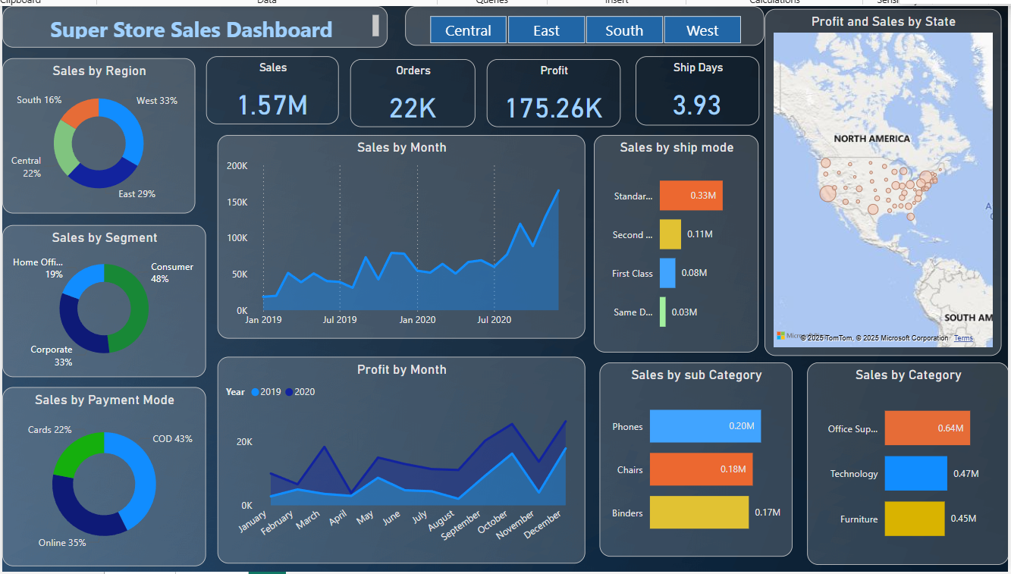

**2.Time Series Forecasting**

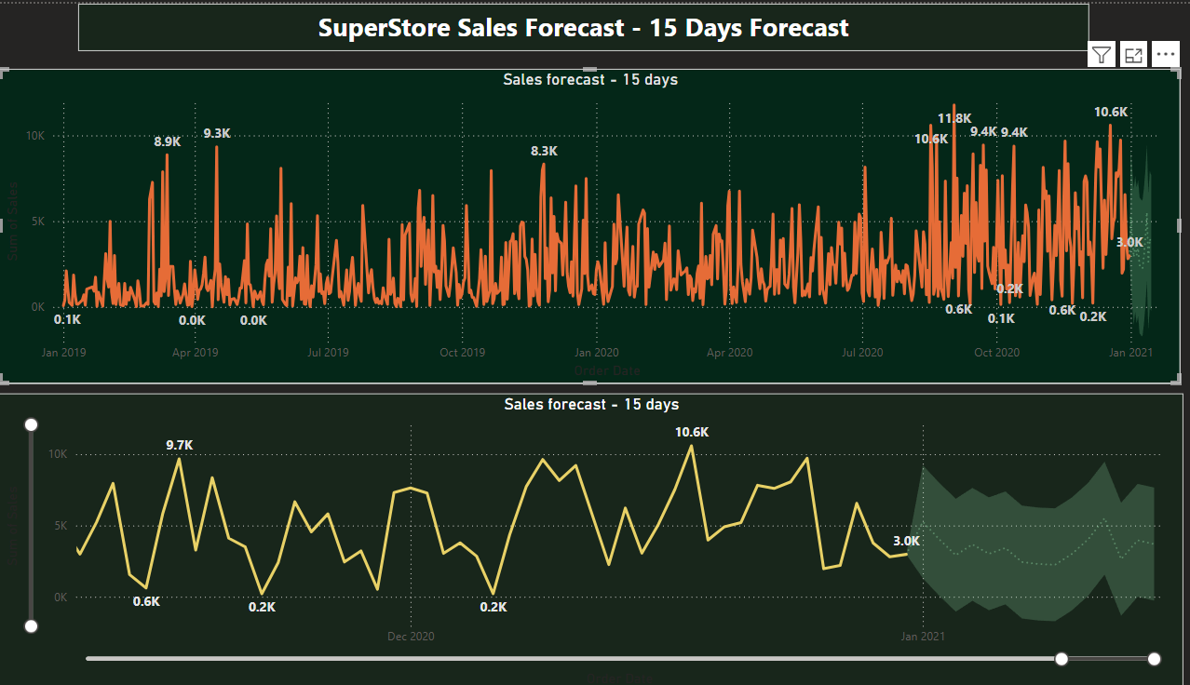

**3.** **Regional Sales Performance**

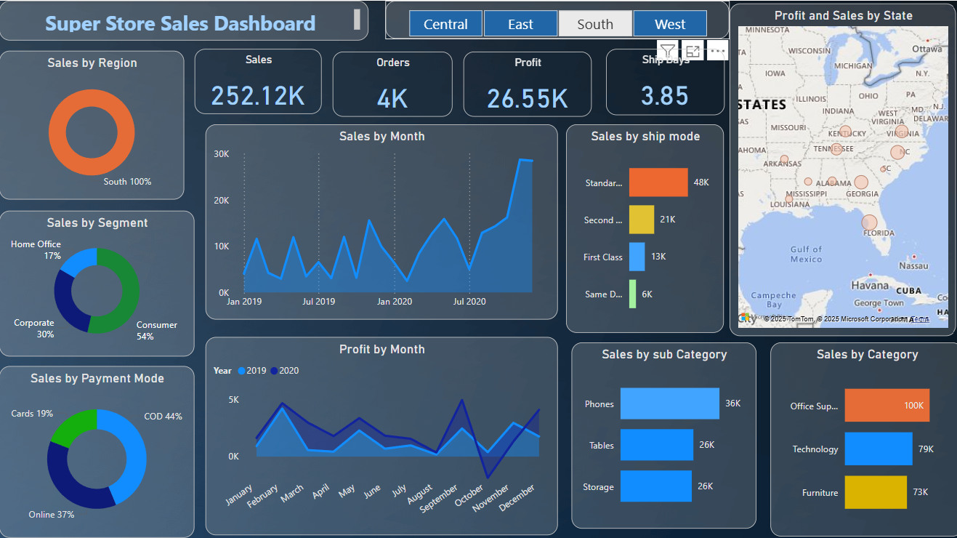

**4.Total Sales Table**

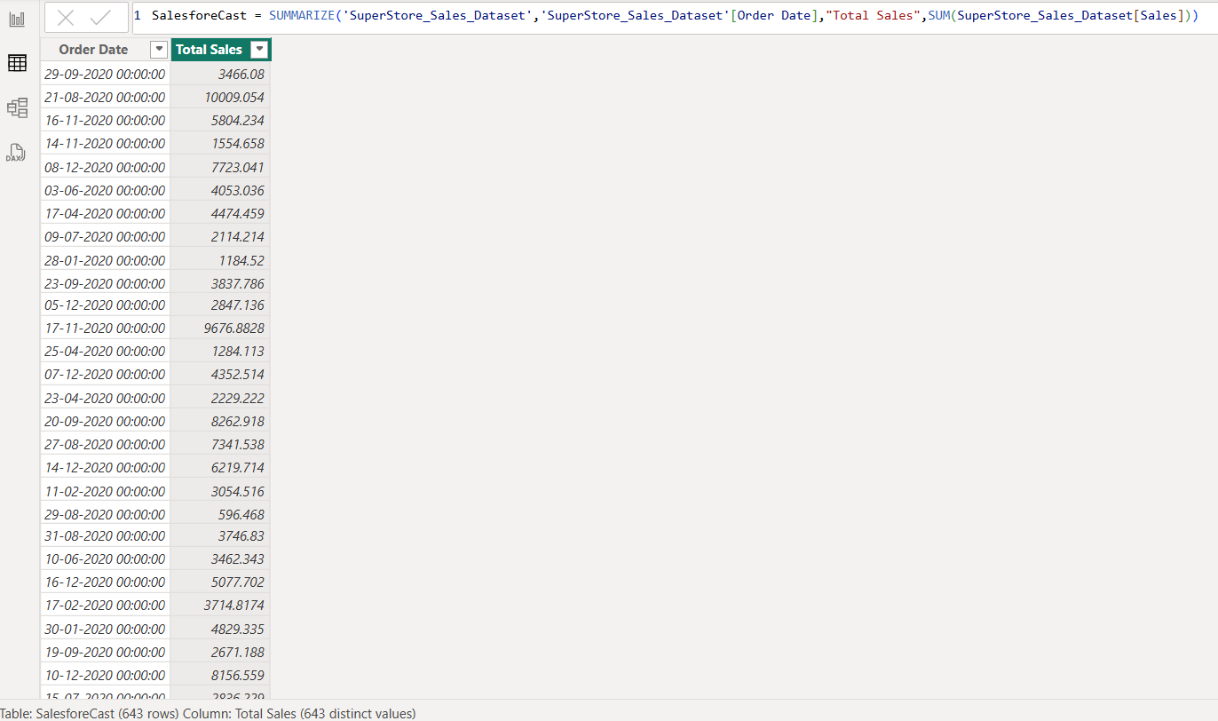

**5.** **Sales Comparison (Year-over-Year/Quarter-over-Quarter)**

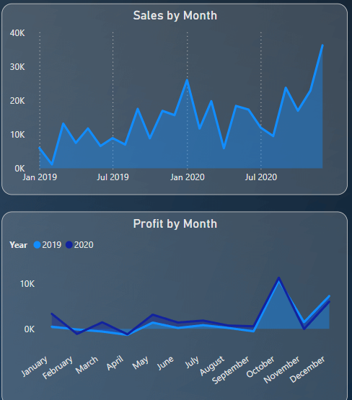

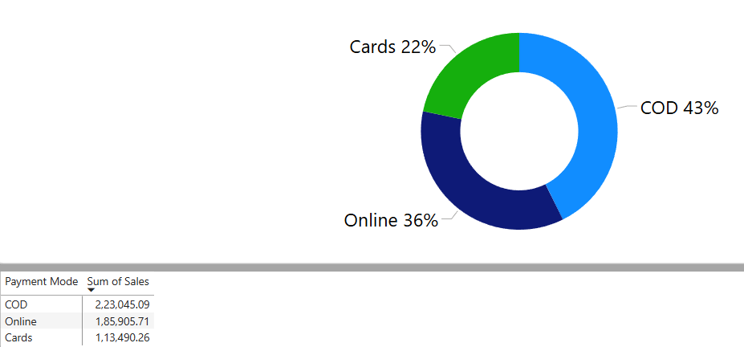**6. Payment Method Breakdown**

1. **SuperStore Detail Table**

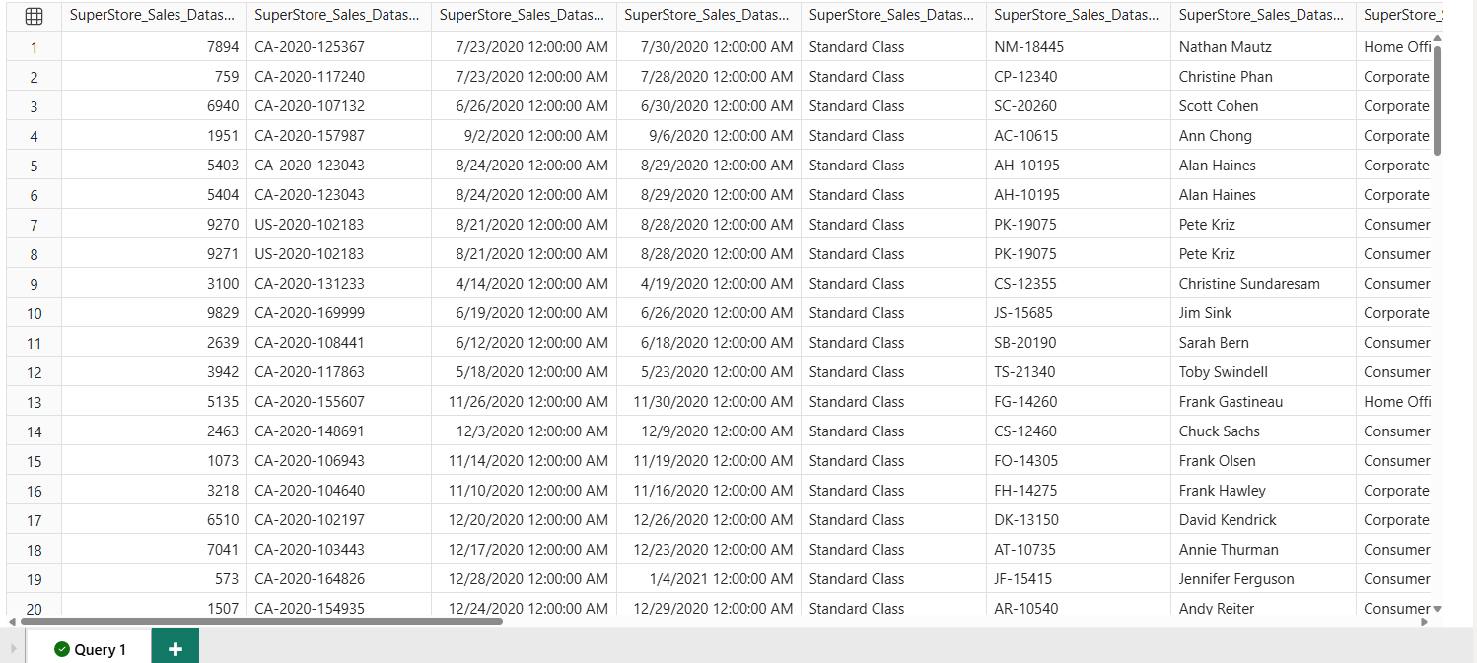

**9.Total Orders**

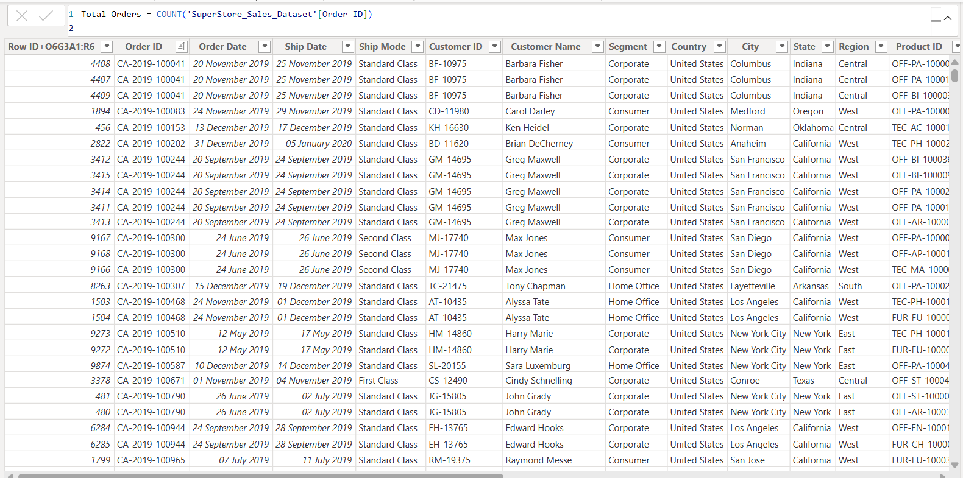

**Appendix B: DAX Formulas Used**

1. Total Orders



1. Average Delivery

* **Appendix C: Data Model Diagram**

**Power BI model view with relationships marked**

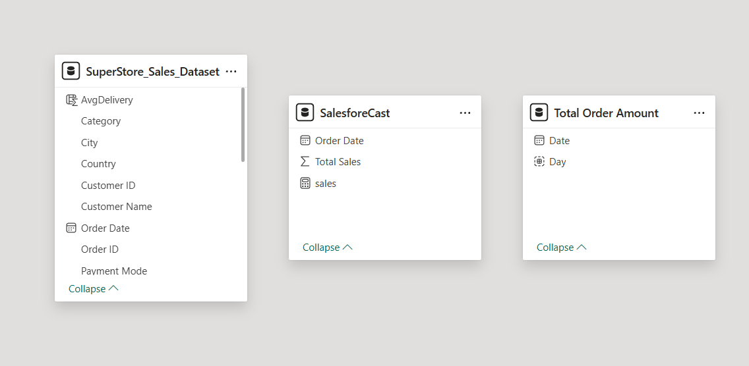

**Appendix D: Glossary**

* **KPI: Key Performance Indicator**

The KPIs evaluate an association’s performance in different areas by assessing quantifiable measure values. In businesses, KPIs play an essential part as visual cues that indicate growth by assessing values and measurable pretensions. A KPI always has a base value or measure which is estimated against a target value. That is, comparing the factual performance with the target set. You can estimate the performances in an analysis just by seeing the KPIs.

**KPI Advantages**

* Monitoring the target: This KPI helps the organization to monitor their performance in a visuals manner
* Timely reports: With This KPI the organization will be able to check whether they are able to execute their plan or not
* Simplify Process: Modern businesses can use KPIs for their advancement of profit

**Uses of KPI**

Working with KPIs is easy and you can use them to display inversely complex information. The two main reasons why you should use KPIs in your Power BI are

* We use KPIs to measure progress i.e., positive or negative change over time. For illustration – whether you’re getting correct results or not, meeting targets or lagging before.
* We also use KPIs to measure the distance to a target or a thing. In this case, you dissect how far behind you’re in meeting your target.
* **DAX: Data Analysis Expressions**

DAX is a formula and query language that is designed to work with tabular data models and is primarily used to simplify data analysis and calculation tasks in [Power BI](https://www.geeksforgeeks.org/power-bi-tools-and-functionalities/), Microsoft PowerPivot, SQL, and Server Analysis Services (SSAS). It provides users with the ability to create sophisticated calculations, define custom metrics, and perform complex data manipulations.DAX has many powerful functions which Excel does not have.

-Importance of DAX

DAX provides tools and features that enable flexible and customized data analysis, reporting, and modeling capabilities.

* Advanced Calculations and Data Analysis: DAX provides a comprehensive set of functions and operators for performing advanced calculations and data analysis tasks on large datasets. It allows users to create complex formulas and expressions, enabling calculations that go beyond simple arithmetic operations. With DAX, you can perform aggregations, apply conditional logic, perform statistical calculations, and more.
* Integration with Microsoft Tools: DAX is the formula language used in Microsoft’s business intelligence tools like Power BI and Power Pivot. It seamlessly integrates with these tools, allowing users to leverage DAX’s capabilities for data modeling, calculations, and analysis within a familiar environment.
* Flexibility and Customization: DAX offers a high degree of flexibility and customization options. Users can define calculated columns, measures, and tables to create custom calculations and derive insights specific to their business requirements. This flexibility enables users to tailor their analysis and reporting to the unique needs of their organization.
* **ETL: Extract, Transform, Load**

The Extract Transfom And Load process extracts, transforms, and loads data from multiple sources to a data warehouse or a unified data repository. This centrally collected data in the repository makes it easier to analyze and handle it further. It also acts as a single point for teams’ and businesses’ accurate and consistent data requirements.

**Need for Extract Transform Load**

* **Data Integration:** Power BI ETL allows you to combine data from multiple sources into a unified format for better analysis.
* **Data Transformation:** Enables cleaning, filtering, and transforming raw data into a usable format, ensuring data quality and consistency.
* **Performance Optimization:** By transforming data and pre-processing it, ETL reduces the load on Power BI during analysis, leading to faster performance.
* **Automation of Data Processes:** Power BI’s ETL process can automate repetitive data preparation tasks, saving time and reducing manual errors.
* **Enhanced Data Analytics:** ETL prepares data for advanced analytics and reporting, helping businesses derive meaningful insights.
* API: Application Programming Interface

**14.** **Conclusion**

The **SuperStoreSales Dashboard** using Power BI provides a comprehensive and insightful analysis of sales performance, customer behavior, and product trends. The project demonstrates how data-driven decision-making can be enhanced by leveraging the powerful capabilities of Power BI, a business intelligence tool that allows for dynamic visualization, reporting, and interactive data exploration.

Throughout the project, key metrics such as total sales, revenue trends, product performance, and customer segmentation were analyzed to derive actionable insights for business stakeholders. The interactive features of Power BI, including slicers, filters, and drill-throughs, allowed users to explore the data in real-time, enabling them to make more informed decisions regarding sales strategies, inventory management, and customer targeting.

This project utilized various features of Power BI, such as Data Analysis Expressions (DAX) for creating custom measures and calculations, and Power Query for transforming and cleaning data before it was modeled. The project successfully integrated data from multiple sources, providing a unified view of sales activities and enabling stakeholders to analyze performance across different dimensions such as time, product categories, and regions.

However, as with any project, there are certain limitations that must be acknowledged. Data quality and completeness remain a challenge, as incomplete or inconsistent data can impact the accuracy of the analysis. Additionally, the granularity of the data may not always allow for the most detailed analysis, and the performance of the Power BI dashboards can be affected when dealing with large datasets or complex calculations. The integration of external data sources and the dependencies on user interpretation also pose challenges to the full utilization of the reports.

Despite these limitations, the **SuperStore Sales Analysis** offers valuable insights and highlights the importance of data visualization and business intelligence tools in transforming raw data into actionable business insights. Moving forward, improvements in data quality, the integration of real-time data, and enhancements in dashboard performance can further strengthen the project's value. By continuously refining the data and optimizing the Power BI reports, businesses can unlock even deeper insights that drive growth, improve efficiency, and facilitate more strategic decision-making.

In conclusion, the **SuperStoreSales Dashboard** serves as a powerful example of how Power BI can help organizations analyze sales data and make informed, data-driven decisions.

**15. References**

• **Microsoft Power BI Documentation**  
<https://learn.microsoft.com/en-us/power-bi/>

• **Kaggle – Superstore Sales Dataset**  
<https://www.kaggle.com/>

• **SQLBI – Advanced DAX Techniques**  
<https://www.sqlbi.com/>

• **Data.World – Sales Sample Datasets**  
<https://data.world/>

• **Power Query Documentation – Microsoft**  
<https://learn.microsoft.com/en-us/power-query/>